select * from empolyee_092 where gender='f';

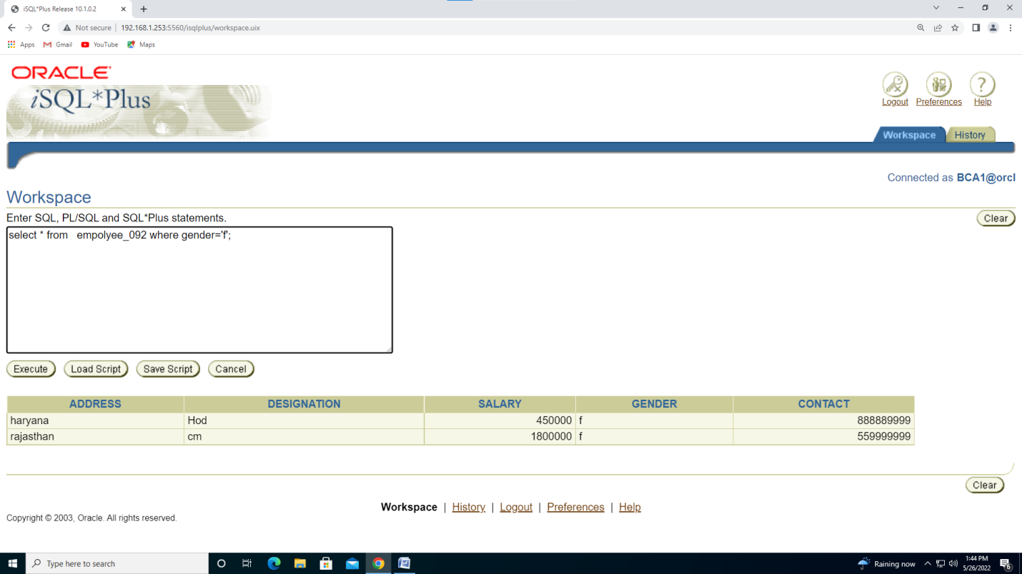

select address, designation from empolyee_092 where gender='f' ;

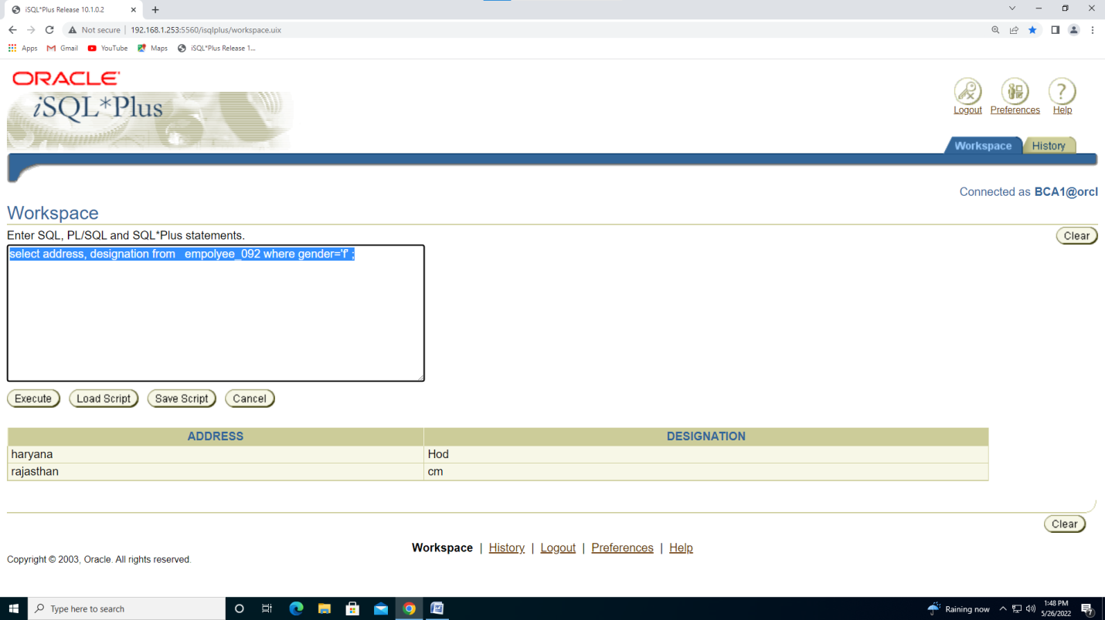

select address, designation from empolyee_092 where salary<3500000;

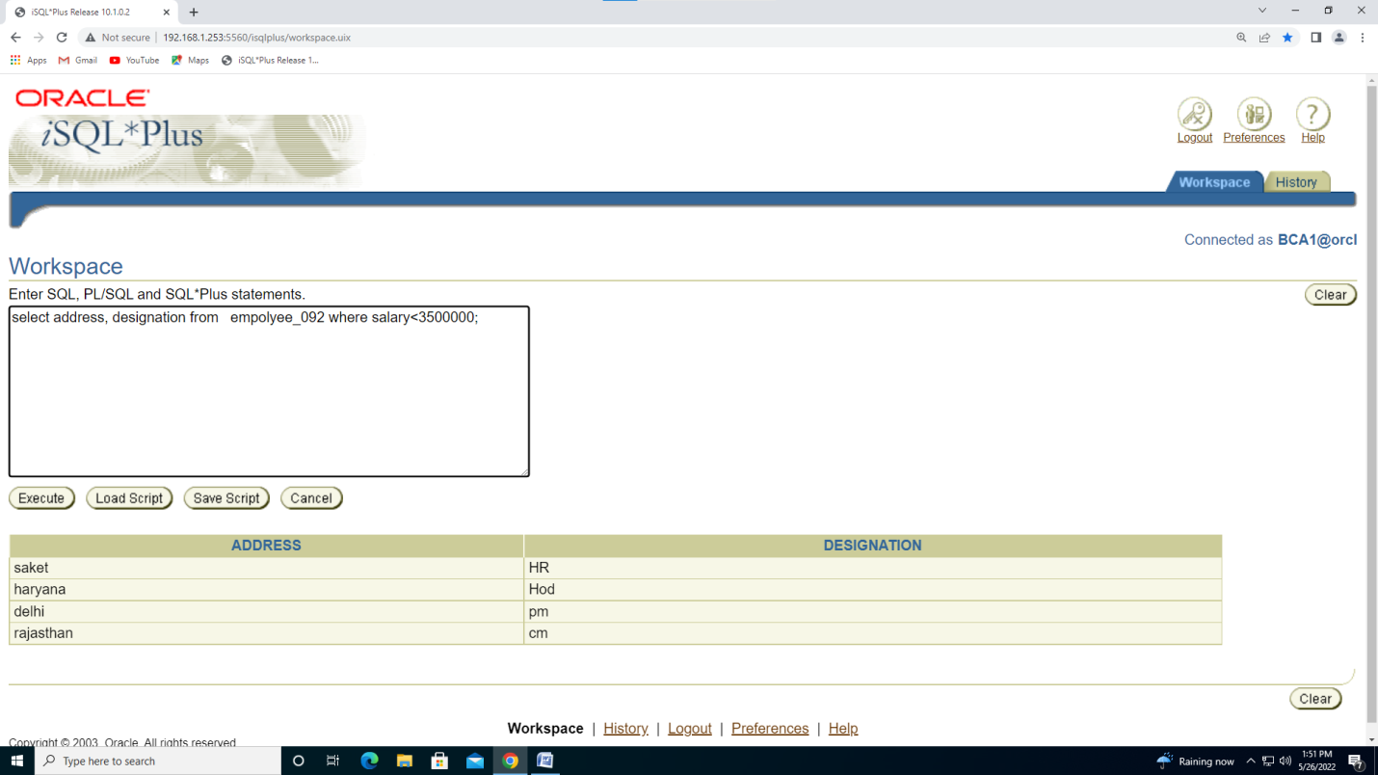

select address,designation from empolyee_092 where address ='saket';

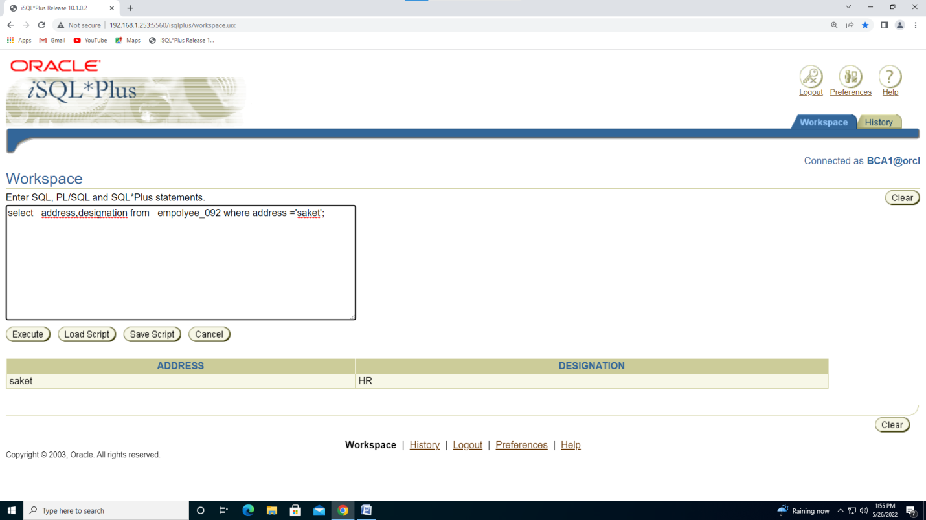

select address,designation from empolyee_092 where not address = 'saket';

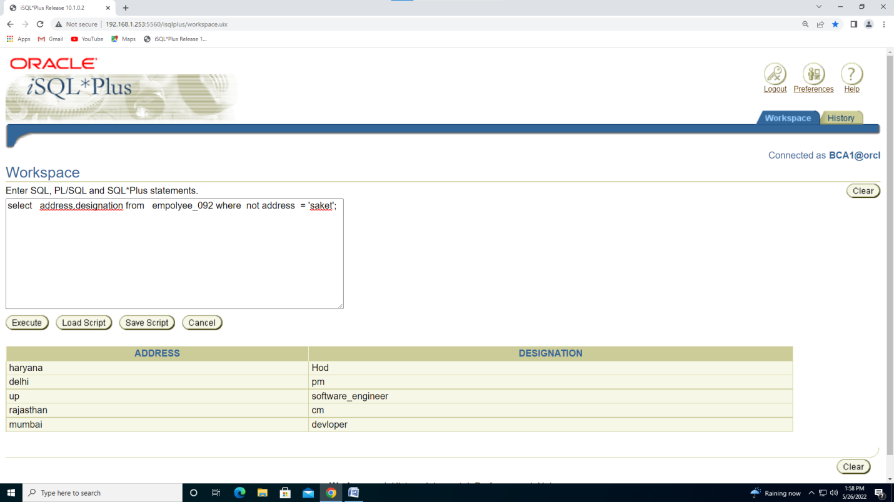

alter table empolyee_092 rename column address to city;

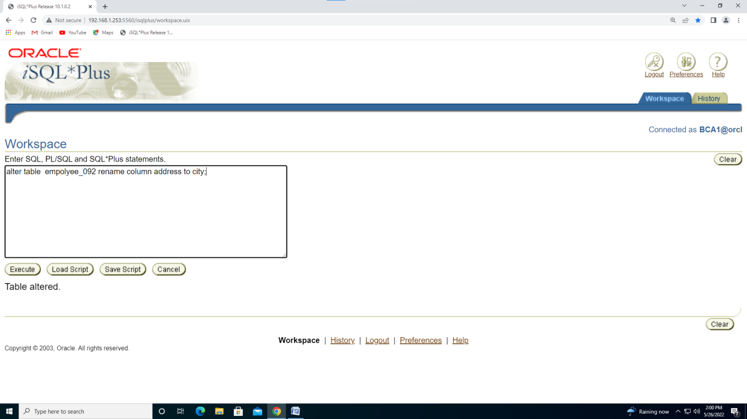

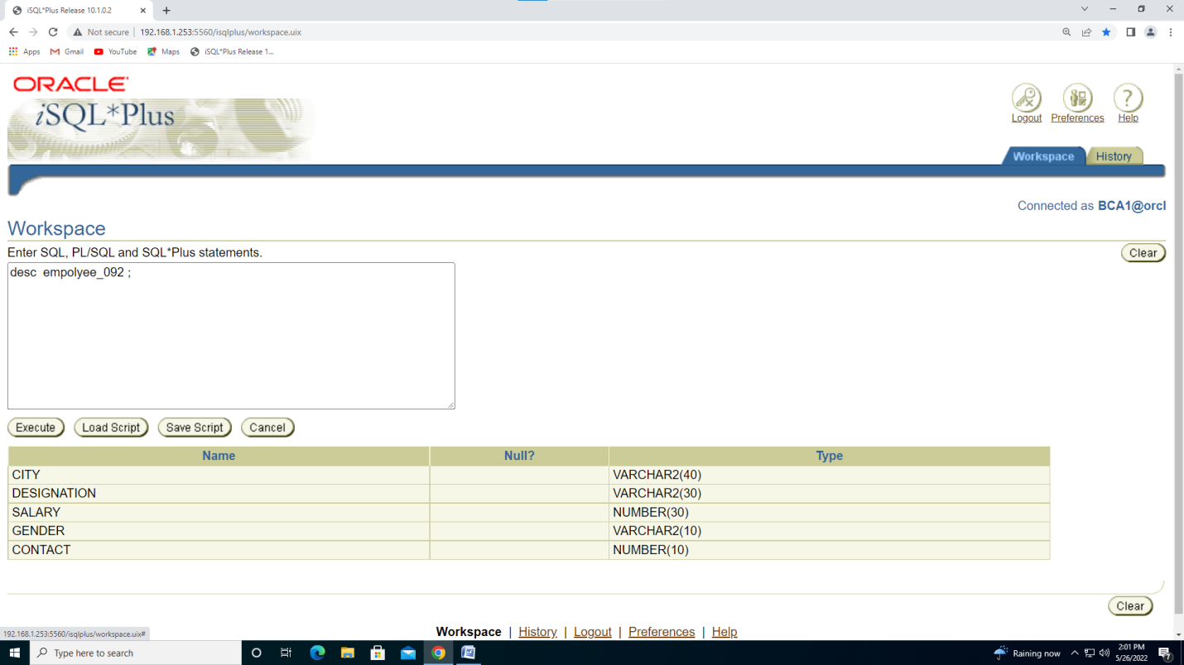

select * from empolyee_092 order by city desc ;

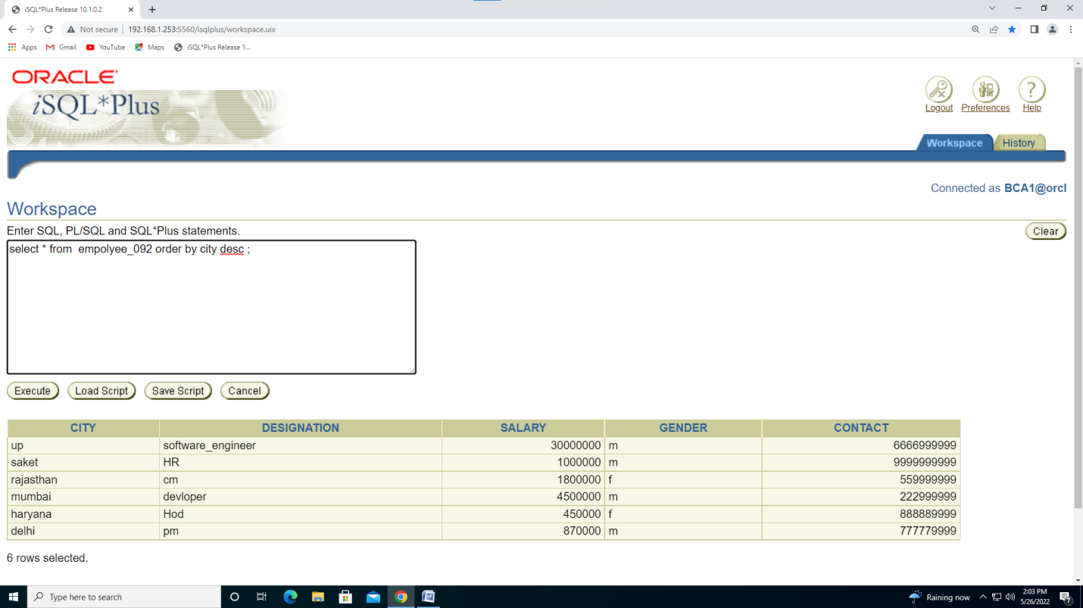

update empolyee_092 set city='jaipur' where city = 'up';

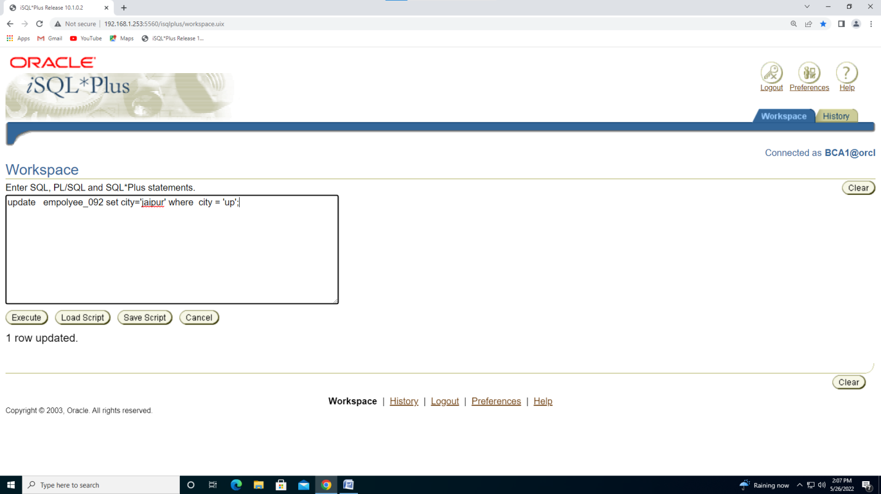

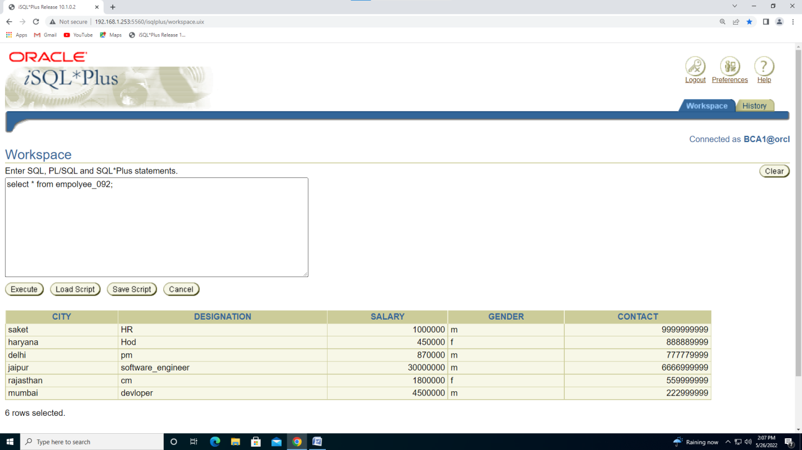

DELETE FROM empolyee_092 WHERE CITY='saket';

